

**HEALTHCARE SYSTEM**

**Software Requirement Specification**

– Hanoi, 09 2022 –

**Table of Contents**

**I. Overview 5**

1. Introduction 5

2. System Functions 6

Screen Flow 6

Screen Details 7

User Authorization 10

Non-Screen Function 12

3. Common Requirements 13

**II. Functional Requirements 13**

1. Public Feature 13

1.1. Home Page 13

1.2. Handbook List 14

1.3. Handbook Detail 15

1.4. Specialty List 16

1.5. Specialty Detail 17

1.6. Medical Facility List 18

1.7. Medical Facility Detail 19

1.8. Doctor List 20

1.9. Doctor Detail 21

2. Common Feature 22

2.1. User Login 21

2.2. User Register 22

2.3. Change Password 23

2.4. Reset Password 24

2.5. User Profile 25

3. Admin Feature 26

3.1. Admin Dashboard 26

3.2. Account List 27

3.3. Account Detail 28

3.4. Handbook List 29

3.5. Handbook Detail 30

3.6. Medical Facility List 31

3.7. Medical Facility Detail 32

3.8. Specialty List 33

3.9. Specialty Detail 34

3.10. Appointment List 35

3.11. Appointment Detail 36

3.12. Feedback List 37

4. Doctor 38

4.1. Appointment List 38

4.2. Patient List 40

4.3. Patient Detail 41

4.4. Feedback List 42

5. Medical Facility 43

5.1. Dashboard 43

5.2. Booking Schedule 44

5.3. Doctor List 44

5.4. Doctor Detail 45

5.5. Appointment List 46

5.6. Appointment Detail 47

5.7. Patient List 48

5.8. Patient Detail 49

5.9. Feedback List 50

6. Patient 51

6.1. Booking Appointment 51

6.2. Appointment List 52

6.3. Appointment Detail 53

6.4. Feedback History 54

**​​RECORD OF CHANGE**

*A - ADDED M - MODIFIED D - DELETED

|  |  |  |  |  |  |
| --- | --- | --- | --- | --- | --- |
| **Effective Date** | **Changed Items** | **A\***  **M, D** | **Change Description** | **Feature** | **New Version** |
| **14/09/2022** | Create new SRS | **A** | Create new |  |  |

# I. Overview

General information about the project:

* Project name: **Health Care System**
* Group name: **Group 6**
* Software type: **Website**

## 1. Introduction

Today, many diseases are born due to the influence of environmental pollution, diseases that spread quickly and widely, such as the current Covid-19 pandemic. It is extremely dangerous for us to go to public places such as hospitals and clinics to queue up, potentially posing a risk of infection. The Health Care system is expected to help patients who come to the medical facilities to limit their close contact in public places, especially the system has services to help visitors quickly book an appointment with a doctor that is effective and safe.

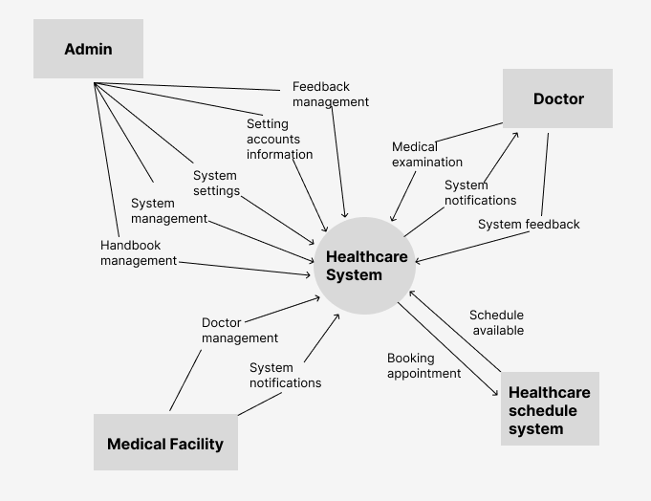

***Image 1.1****: Context of HealthCare system*

## 2. System Functions

### Screen Flow

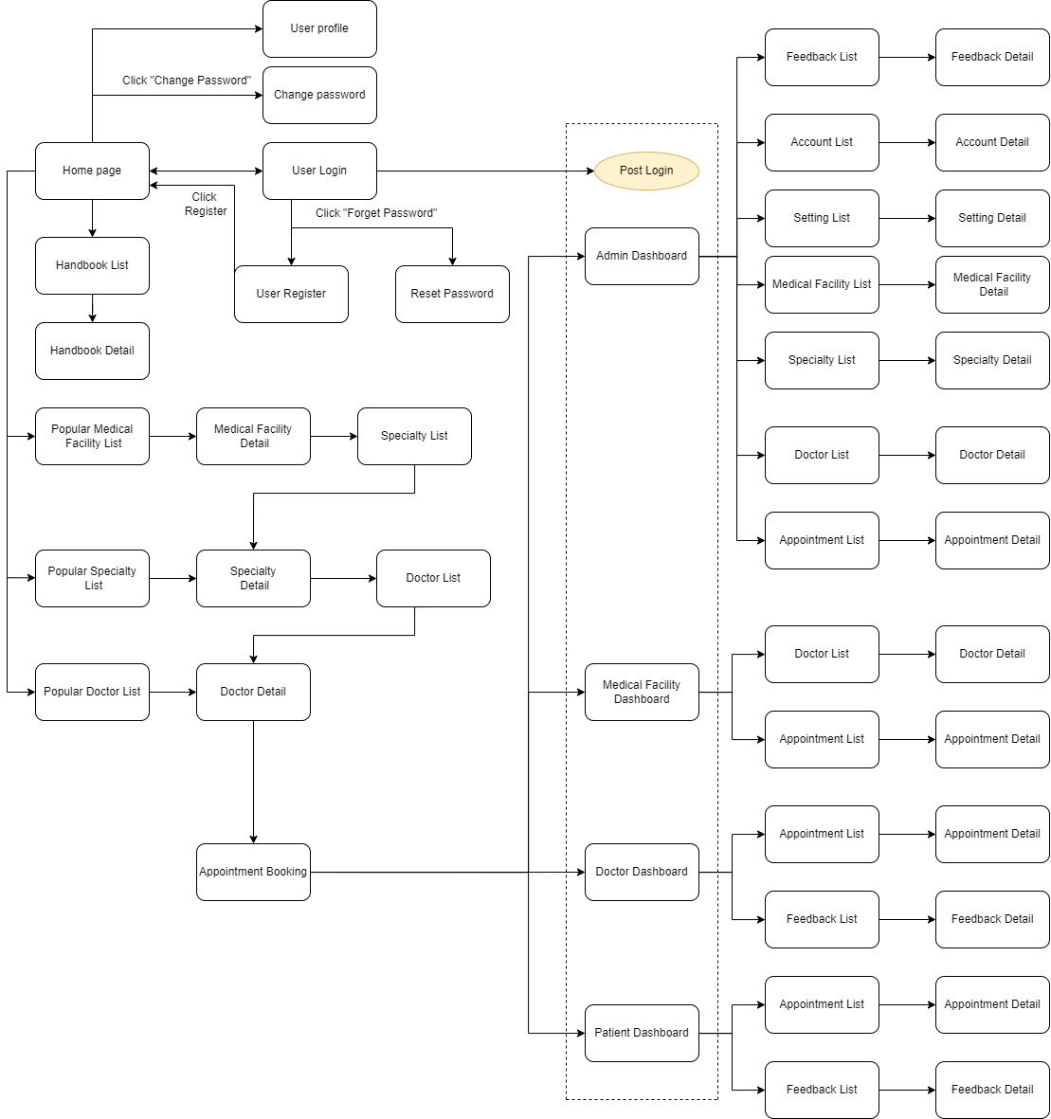

***Image 1.2****: Screen flow of health care system*

### Screen Details

|  |  |  |  |
| --- | --- | --- | --- |
| **No** | **Feature** | **Screen** | **Description** |
| 1 | Public | Home Page | The starting page of the system |
| 2 | Public | Handbook List | List of handbooks |
| 3 | Public | Handbook Detail | Detail of the handbook |
| 4 | Public | Specialty List | List of the specialties |
| 5 | Public | Specialty Detail | Details of specialty |
| 6 | Public | Medical Facility List | List of the medical facilities |
| 7 | Public | Medical Facility Detail | Details of medical facility |
| 8 | Public | Doctor List | List of the doctor |
| 9 | Public | Doctor Detail | Details of doctor |
| 10 | Common | User Login | Authenticate the user to give him/her to access authorized features later on |
| 11 | Common | User Register | Register a new user into the system, verified by the registered email |
| 12 | Common | Reset Password | Use in case the user forgot his/her password |
| 13 | Common | Change Password | Change user’s login password |
| 14 | Common | User Profile | View & edit/update user profile |
| 15 | Common | User Authorization | Authorization user into the system functions based on his/her role |
| 16 | Patient | Booking Appointment | Patient booking appointment |
| 17 | Patient | Appointment List | For patient to view his/her submitted appointments |
| 18 | Patient | Appointment Detail | Show patient appointment details, the patient can edit or cancel the appointment when it is still in the submitted status |
| 19 | Patient | Feedback History | List, view, edit, delete the feedback |
| 20 | Medical Facility | Dashboard | Graphs & Statistics of Doctors, Patients, Appointments, and Revenue |
| 21 | Medical Facility | Booking Schedule | Medical facility can book the time for doctors |
| 22 | Medical Facility | Doctor List | List, filter, search, show, hide, view the doctor of medical facility |
| 23 | Medical Facility | Doctor Detail | View & edit the details of a specific doctor |
| 24 | Medical Facility | Appointment List | List, filter, show, hide, view the appointment. The facility can “Confirm/Cancel” the appointment if doctor have the request |
| 25 | Medical Facility | Appointment Detail | Show detail of appointment |
| 26 | Medical Facility | Feedback List | List, filter, show the feedback of patient about doctor. |
| 27 | Medical Facility | Patient List | List, filter, search, show, hide, view patient (s) of facility |
| 28 | Medical Facility | Patient Detail | View the details of a patient & history of examination in facility |
| 29 | Doctor | Appointment List | List, filter, search, show, hide, view appointment. The doctor can “Confirm/Cancel” the appointment |
| 30 | Doctor | Appointment Detail | Show detail of appointment |
| 31 | Doctor | Patient List | List, filter, search, show, hide, view patient (s) of doctor |
| 32 | Doctor | Patient Detail | View the details of a patient & history of examination in facility |
| 33 | Doctor | Feedback List | List, filter, search, show, hide, view feedback(s) |
| 34 | Admin | Medical Facility List | List, filter, search, show, edit, delete, add medical facilities |
| 35 | Admin | Medical Facility Detail | Show detail of medical facility |
| 36 | Admin | Specialty List | List, search, show, delete, add specialty |
| 37 | Admin | Specialty Detail | Show, edit detail of specialty |
| 38 | Admin | Appointment List | List, filter, search, show appointments |
| 39 | Admin | Appointment Detail | Show detail of appointment |
| 40 | Admin | Handbook List | List, filter, search, delete handbook(s) |
| 41 | Admin | Handbook Detail | View & edit the details of a handbook |
| 42 | Admin | Feedback List | List, filter, search, delete feedback(s) |
| 43 | Admin | Account List | List, search, show, delete, add account |
| 44 | Admin | Account Detail | Show information detail of account |
| 45 | Admin | Admin Dashboard | Graphs & Statistics of Doctors, Patients, Appointments, and Revenue |

***Table 1.1****: Screen detail table of health care system*

### User Authorization

|  |  |  |  |  |  |
| --- | --- | --- | --- | --- | --- |
| **Screen** | **Admin** | **Medical Facility** | **Doctor** | **Patient** | **Guest** |
| Home Page | X | X | X | X | X |
| Handbook List | X | X | X | X | X |
| Handbook Detail | X | X | X | X | X |
| Specialty List | X | X | X | X | X |
| Specialty Detail | X | X | X | X | X |
| Medical Facility List | X | X | X | X | X |
| Medical Facility Detail | X | X | X | X | X |
| Doctor List | X | X | X | X | X |
| Doctor Detail | X | X | X | X | X |
| User Login | X | X | X | X | X |
| User Register | X |  |  | X | X |
| Reset Password | X | X | X | X |  |
| Change Password | X | X | X | X |  |
| User Profile | X | X | X | X |  |
| Booking Appointment |  |  |  | X |  |
| Appointment List |  |  |  | X |  |
| Appointment Detail |  |  |  | X |  |
| Feedback History |  |  |  | X |  |
| Medical Facility Dashboard |  | X |  |  |  |
| Medical Facility Booking Schedule |  | X |  |  |  |
| Doctor List |  | X |  |  |  |
| Doctor Detail |  | X |  |  |  |
| Appointment List |  | X |  |  |  |
| Appointment Detail |  | X |  |  |  |
| Feedback List |  | X |  |  |  |
| Patient List |  | X |  |  |  |
| Patient Detail |  | X |  |  |  |
| Appointment List |  |  | X |  |  |
| Appointment Detail |  |  | X |  |  |
| Patient List |  |  | X |  |  |
| Patient Detail |  |  | X |  |  |
| Feedback List |  |  | X |  |  |
| Medical Facility List | X |  |  |  |  |
| Medical Facility Detail | X |  |  |  |  |
| Specialty List | X |  |  |  |  |
| Specialty Detail | X |  |  |  |  |
| Appointment List | X |  |  |  |  |
| Appointment Detail | X |  |  |  |  |
| Handbook List | X |  |  |  |  |
| Handbook Detail | X |  |  |  |  |
| Feedback List | X |  |  |  |  |
| Account List | X |  |  |  |  |
| Account Detail | X |  |  |  |  |
| Admin Dashboard | X |  |  |  |  |

***Table 1.2****: User authorization table of health care system*

### Non-Screen Function

|  |  |  |  |
| --- | --- | --- | --- |
| **#** | **Feature** | **System Function** | **Description** |
| 1 | Common | Sign out | Users sign out of the system |
| 2 | Common | User Authorization | This is the authorization mechanism in the system |

***Table 1.3****: Non-screen function table of health care system*

#### 

## 3. Common Requirements

The web displays Vietnamese characters.

# II. Functional Requirements

## 1. Public Feature

#### 1.1. Home Page

● Function trigger: This function is triggered when the user visits the website or the system homepage

● Function description: Users see briefs about introduction, top 10 services, top 10 doctors, the system's specialities.

● Screen layout: simulated prototype of the screen, the sample below is for the home screen

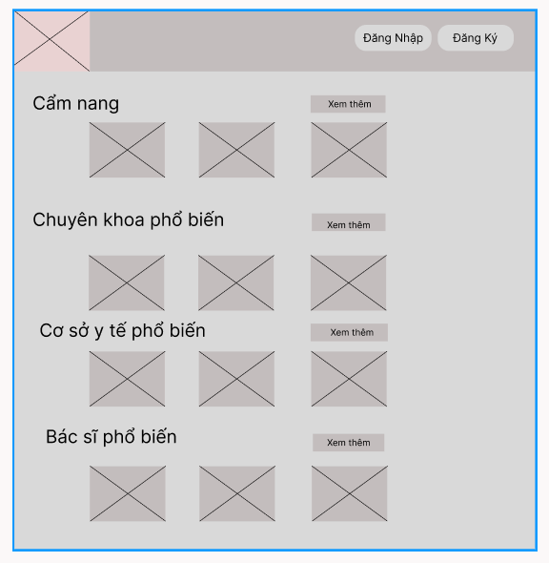

● Function Details: When users access the system, the homepage will appear and show information about the system

#### 1.2. Handbook List

● Function trigger: This function is triggered when the user clicks “Xem thêm” of Handbook list in home page

● Function description: Show the paginated list of handbooks

● Screen layout: mock-up prototype of the screen, sample below is for the handbook screen

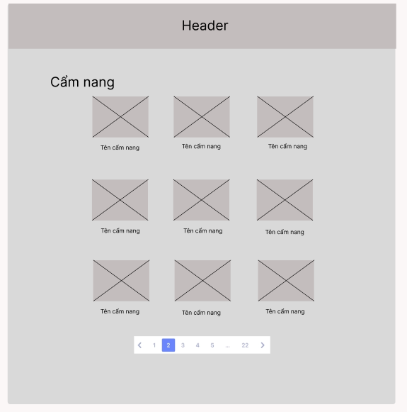

● Function Details:

* Show the handbook pagination (sorted by published date)

#### 1.3. Handbook Details

● Function trigger: This function is triggered when the user clicks to a handbook

● Function description: Show detail information of handbook

● Screen layout: mock-up prototype of the screen, sample below is for the details screen

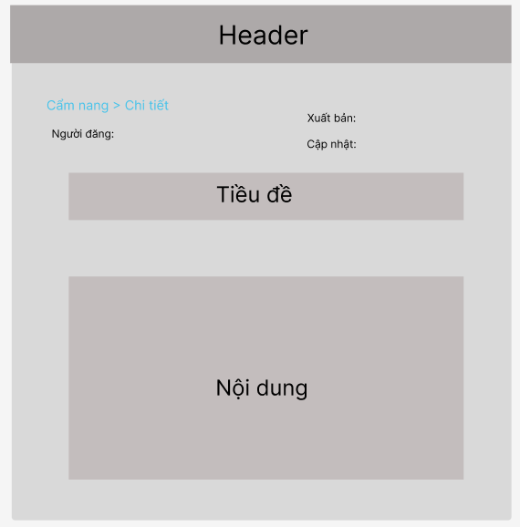

● Function Details:

* Show handbook details (including title, author, published date, updated date, and handbook content)

#### 1.4. Specialty List

● Function trigger: This function is triggered when the user clicks to “Xem thêm” Popular Specialties list in home page

● Function description: Show information list of specialties

● Screen layout: mock-up prototype of the screen, sample below is for the Specialty List screen

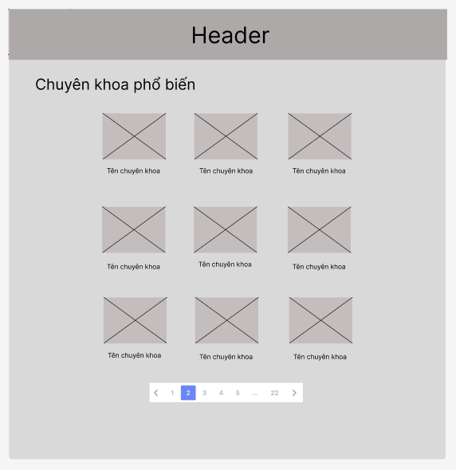

● Function Details:

* List of specialty in the system.
* Shown information of each specialty: image, name.
* User can choose to view Specialty Detail.

#### 1.5. Specialty Details

● Function trigger: This function is triggered when the user clicks to Specialty.

● Function description: View specialty overview information

● Screen layout: mock-up prototype of the screen, sample below is for the Specialty Details screen.

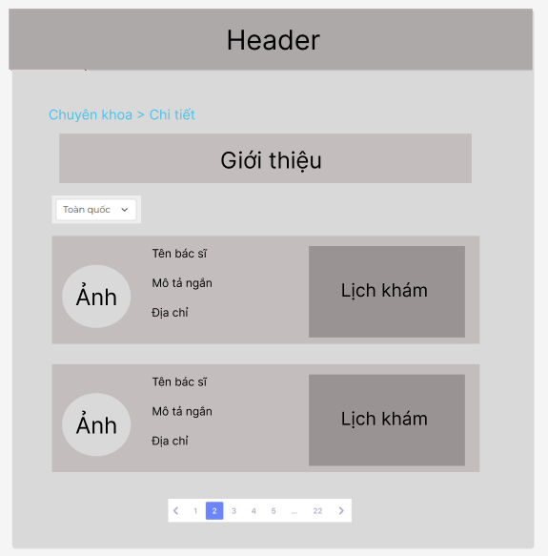

● Function Details:

- Show description about specialty.

- Show list doctors in the specialty filtered by working address of doctor.

- Information of each doctor includes: name, short description, working address and display schedule of doctor.

#### 1.6. Medical Facility List

● Function trigger: This function is triggered when the user clicks to “Xem thêm” Popular Medical Facility list in home page.

● Function description: Show list of medical facilities.

● Screen layout: mock-up prototype of the screen, sample below is for the Medical Facility list screen

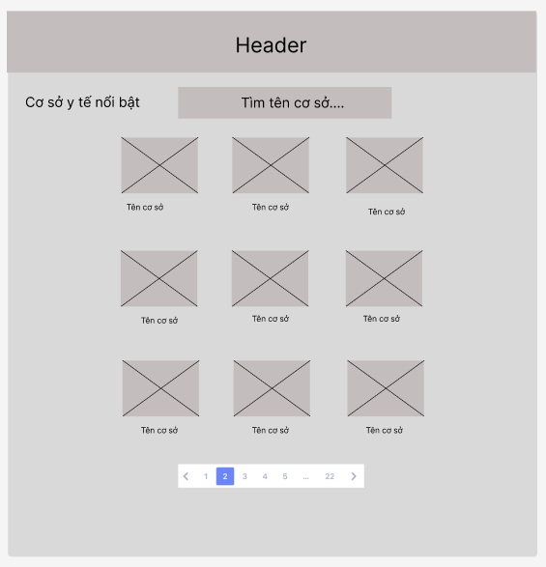

● Function Details:

List of medical facilities in the system:

- Shown information for each facility include: name, image

- User can search by name.

#### 1.7. Medical Facility Details

● Function trigger: This function is triggered when the user clicks to a medical facility

● Function description: View medical facility overview information

● Screen layout: mock-up prototype of the screen, sample below is for the Medical Facility Detail screen

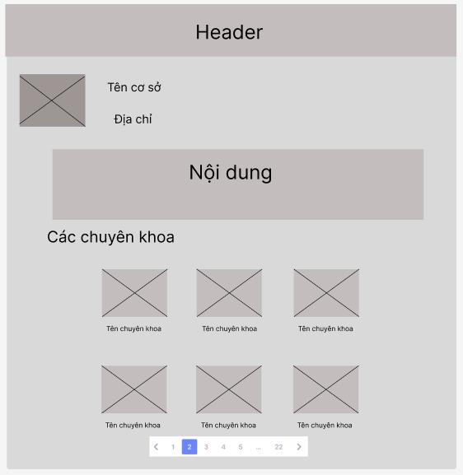

● Function Details:

- View the details of the medical facility contains: name, address.

- Show content include: “Giới thiệu”, “Thế mạnh chuyên môn”, “Trang thiết bị”, “Vị trí”, “Quy trình khám”, “Lưu ý”.

- Show list specialty of medical facility have.

#### 1.8. Doctor List

● Function trigger: This function is triggered when the user clicks to “Xem thêm” of Popular Doctor list in homepage.

● Function description: View list paginated of doctors.

● Screen layout: mock-up prototype of the screen, sample below is for the Doctor List screen

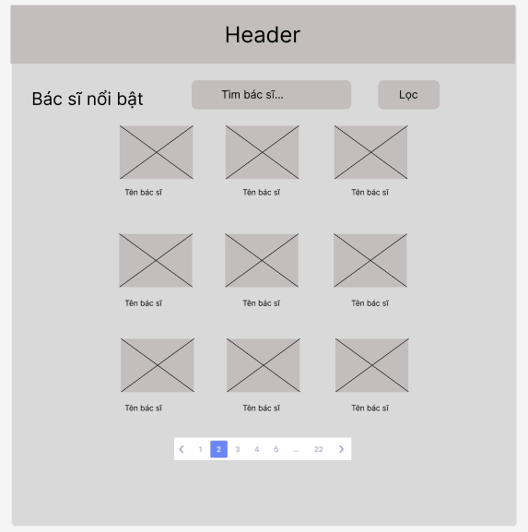

● Function Details:

- Show list doctors, each doctor display name, image.

- User can search by name and filtered by working address of doctor.

#### 1.9. Doctor Detail

● Function trigger: This function is triggered when the user clicks to a doctor

● Function description: View detail information of doctors.

● Screen layout: mock-up prototype of the screen, sample below is for the Doctor Detail screen

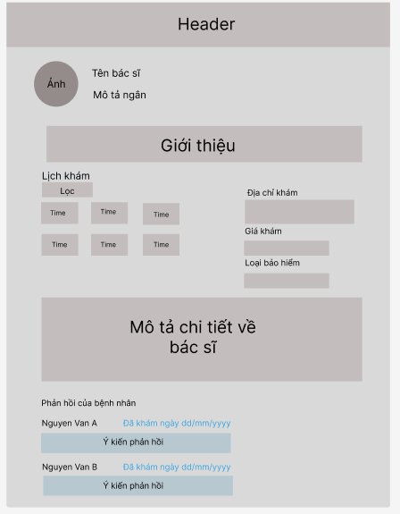

● Function Details:

Show detail information of doctor includes:

- Show avatar, name, short description

- Show schedule of doctor filtered by nearly future date, address, price and type insurance

- Show detail description about doctor.

- Show feedback(s) of patient(s) about doctor.

- User can view schedule and book an appointment by click a time in schedule of doctor

## 2. Common Feature

#### 2.1. User Login

● Function trigger: This function is triggered when the user clicks Sign in from Homepage

● Function description: User sign in into the system.

● Screen layout: mock-up prototype of the screen, sample below is for the Sign in screen

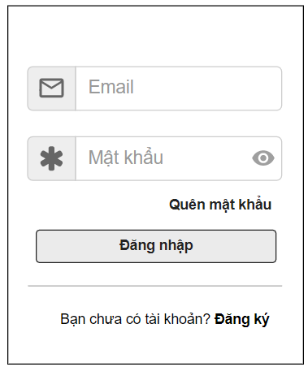

Function Details: When the user is in the state not logged in, at the home page there will be a Sign in button and after signing in into the system, the Sign in button will become Sign out.

#### 2.2. User Register

● Function trigger: This function is triggered when the guest goes to login and choose to register or click register button in homepage

● Function description: The guest can create an account.

● Screen layout: mock-up prototype of the screen, sample below is for the Register.

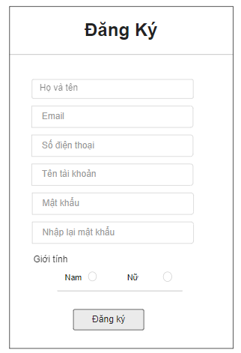

Function Details: After going to the login, the guest can create an account.

#### 2.3. Change Password

* Function trigger: This function is triggered when the user clicks “Tài khoản của tôi” from avatar in Homepage
* Function description: Show profile
* Screen layout: simulated prototype of screen, below sample is for Change Password screen

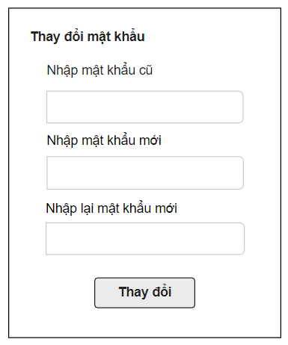

Function Details: Allows the user to change his/her password by inputting his current password as well as new password (twice)

#### 2.4. Reset Password

* Function trigger: This function is triggered when the user clicks “Quên mật khẩu” from Login screen
* Function description: The user can Forgot Password to an account.
* Screen layout: simulated prototype of screen, below sample is for Reset Password screen

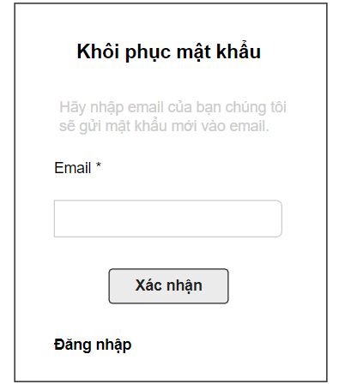

**Function Details**:The user can input his/her email to receive the reset password link.

#### 2.5. User Profile

* Function trigger: This function is triggered when the user clicks “Tài khoản của tôi” from Home
* Function description: The user can edit his/her profile information, including the registered user information and the avatar image.
* Screen layout: simulated prototype of screen, below sample is for User profile screen

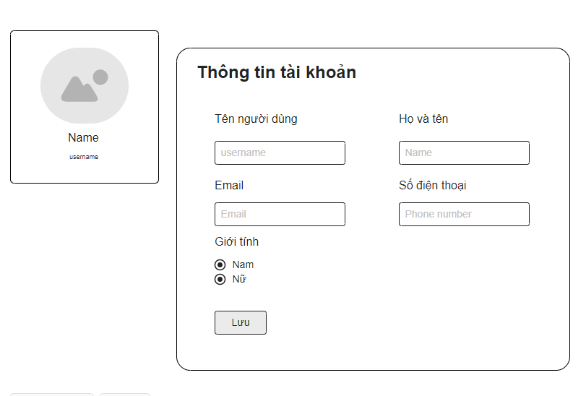

**Function Details**:The user can edit his/her profile information.

## 3. Admin Feature

#### 3.1. Dashboard

● **Function trigger**: When a user logs in as admin, the admin chooses “Bảng điều khiển”

* **Function description**: Show dashboard
* **Screen layout**: simulated prototype of screen, below sample is for dashboard screen

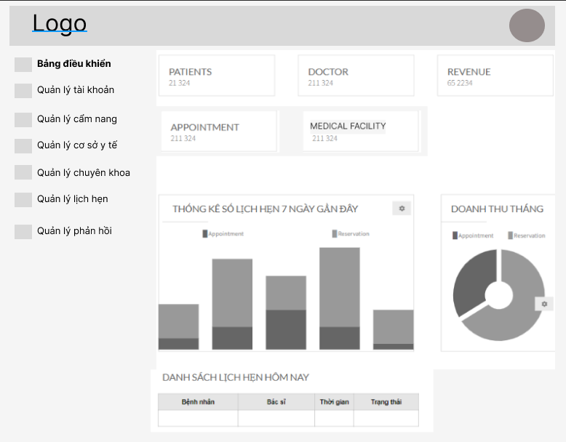

* **Function Details**:

- Graphs & Statistics of Doctors, Patients, Appointments, and Revenue

- List of today related appointments (Patient name, doctor name, date/time, Status

#### 3.2. Account List

* **Function trigger**: When a user logs in as admin, the admin chooses “Quản lý tài khoản” feature
* **Function description**: Account list feature displays a list of all accounts created on the system including Admin, Patient, Doctor.
* **Screen layout**: simulated prototype of screen, below sample is for admin setting screen

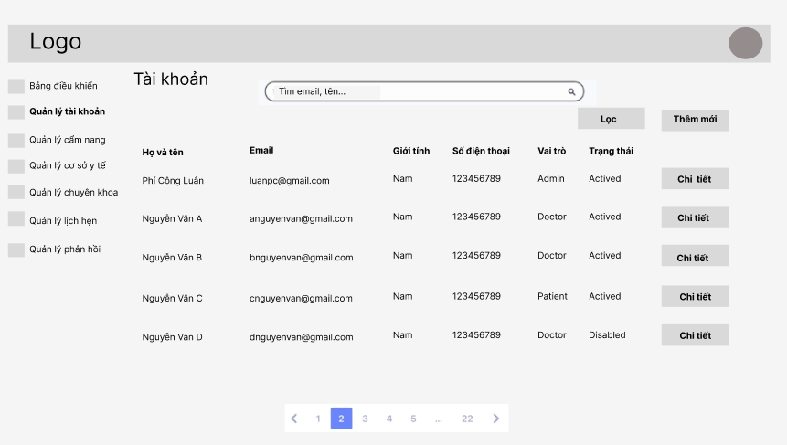

* **Function Details**: Allow the admin to search account name, display list account and edit account of admin, patient or doctor

#### 3.3. Account Detail

* **Function trigger**: When a user logs in as admin, the admin chooses “Quản lý tài khoản” feature and click on an account in list account to see detail information
* **Function description**: Account detail feature displays user details information
* **Screen layout**: simulated prototype of screen, below sample is for admin setting screen

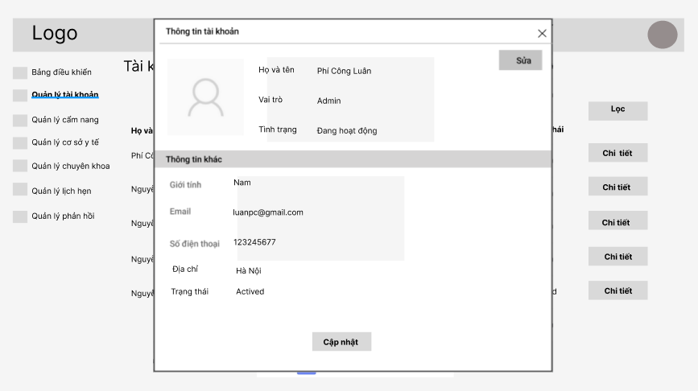

* **Function Details**: Allow the admin can view and edit user accounts in the Doctris system includes “Họ và tên”, “Vai trò”, “Tình trạng”, “Giới tính”, “Email”, “Số điện thoại”, “Địa chỉ” , “Trạng thái”

#### 3.4. Handbook List

● **Function trigger**: This function is triggered when the admin clicks “Quản lý cẩm nang” in navbar

● **Function description**: Show the paginated list of handbook

● **Screen layout**: mock-up prototype of the screen, sample below is for the Handbook list screen

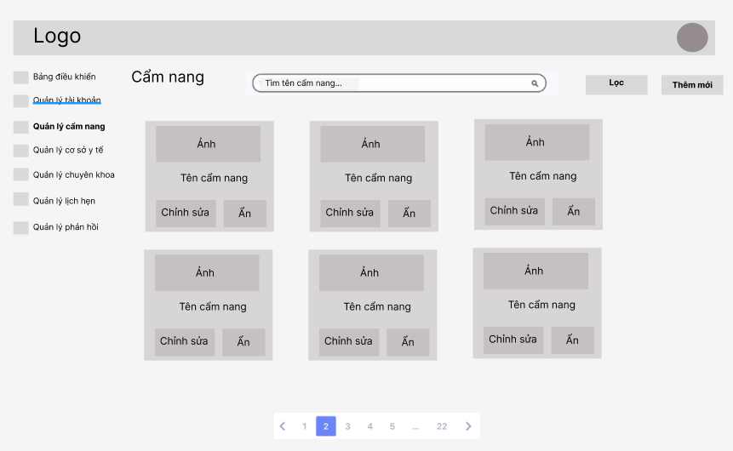

* **Function Details**:

- Show the paginated list of handbooks (include handbook' id, thumbnail, title)

- The user can filter the handbook by date.

- User can search by name of handbook.

- The list can be filtered by date or status

- The page also have the button/link that allows the user to add new or choose to view/update/show/hide an existing handbook

#### 3.5. Handbook Detail

● **Function trigger**: This function is triggered when the admin clicks a handbook

● **Function description**: Show detail of handbook

● **Screen layout**: mock-up prototype of the screen, sample below is for the Detail Handbook screen

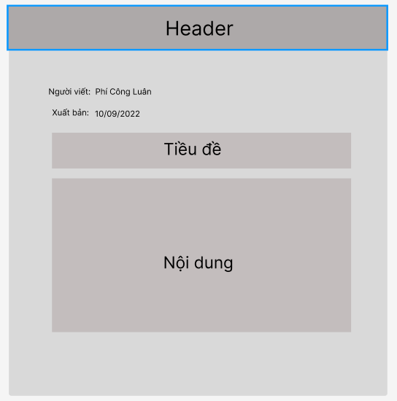

* **Function Details**:

- Show detail of handbook: author, published date, title, content

#### 3.6. Medical Facility List

● **Function trigger**: This function is triggered when the admin clicks “Quản lý cơ sở y tế” in navbar.

● **Function description**: Show list of medical facilities.

● **Screen layout**: mock-up prototype of the screen, sample below is for the Medical Facilities List screen

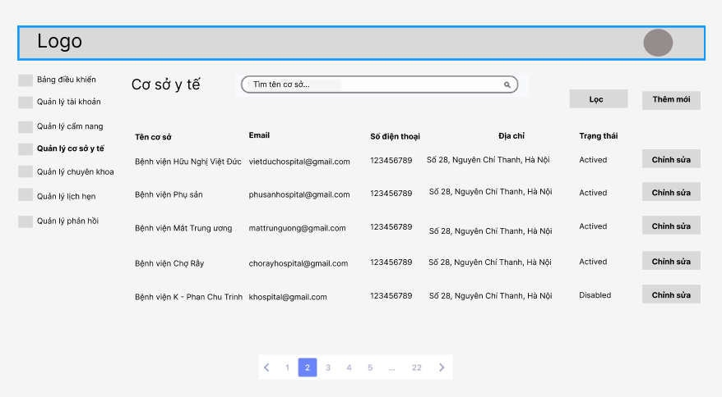

* **Function Details**:

- Show detail of medical facility: name, email, phone number, address, status

- Show button/link for user to click to add new/edit facility

- Show filtered by status

#### 3.7. Medical Facility Detail

● **Function trigger**: This function is triggered when the admin clicks “Chỉnh sửa” of a medical facility

● **Function description**: Show detail of medical facilities.

● **Screen layout**: mock-up prototype of the screen, sample below is for the Medical Facilities Detail screen

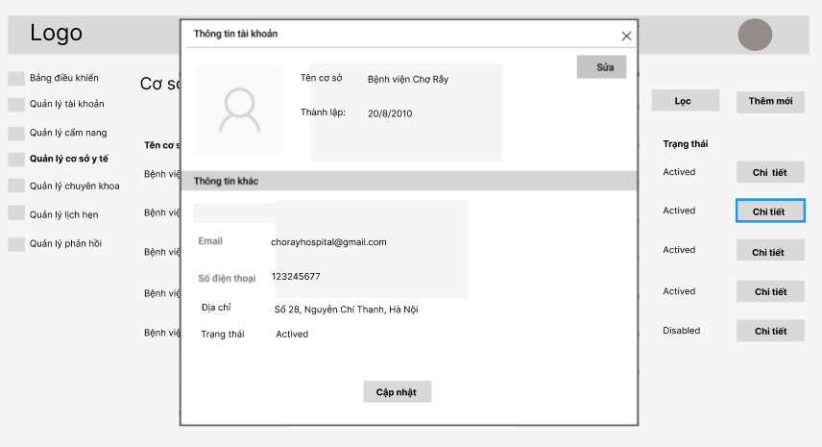

* **Function Details**:

- Show detail of medical facility: name, email, phone number, address, established date

- Admin clicks “Sửa” to enable fields, then clicks “Cập nhật” to confirm editing information of medical facility

#### 3.8. Specialty List

● **Function trigger**: This function is triggered when the admin clicks “Quản lý chuyên khoa” in navbar.

● **Function description**: Show list of specialties.

● **Screen layout**: mock-up prototype of the screen, sample below is for the Specialty List screen

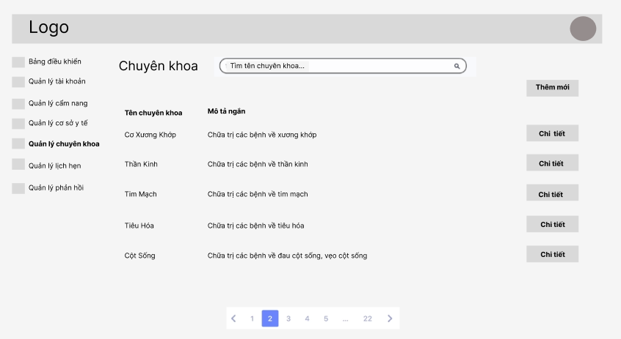

* **Function Details**:

- Show information of special: name, short description.

- Show buttons to add new, view detail specialty.

#### 3.9. Specialty Detail

● **Function trigger**: This function is triggered when the admin clicks “Chi tiết” of a specialty.

● **Function description**: Show detail of specialty.

● **Screen layout**: mock-up prototype of the screen, sample below is for the Specialty Detail screen

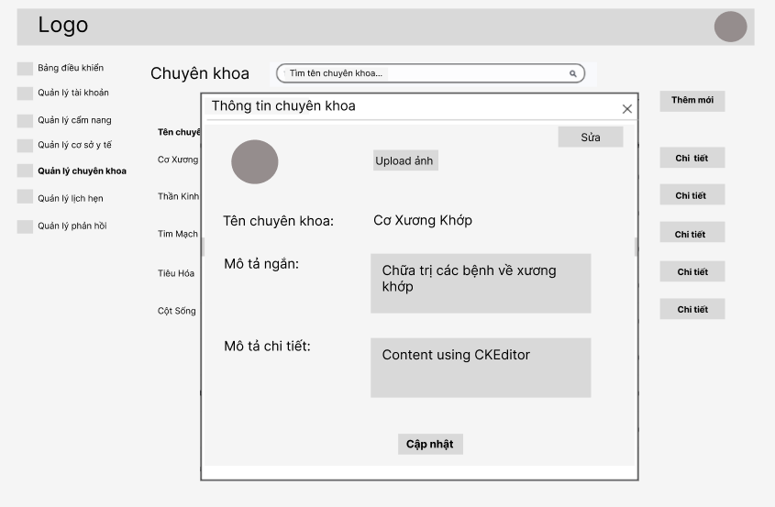

* **Function Details**:

- Show detail of special: avatar, name, short description, detail description.

- Show button “Sửa” to enable fields for admin edit them, button “Cập nhật” to confirm updated information.

#### 3.10. Appointment List

● **Function trigger**: This function is triggered when the admin clicks “Quản lý lịch hẹn” in navbar.

● **Function description**: Show list of appointments

● **Screen layout**: mock-up prototype of the screen, sample below is for the Appointment List screen

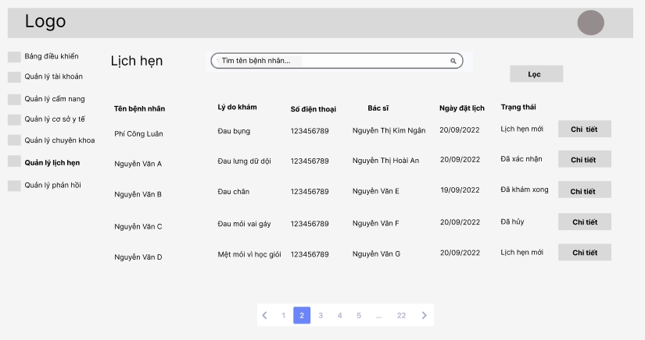

* **Function Details**:

- Show some information of appointment: “Tên bệnh nhân”, “Lý do khám”, “Số điện thoại”, “Bác sĩ”, “Ngày đặt lịch”, “Trạng thái”

- Show button “Lọc” for admin to filtered by date, status.

- Show button “Chi tiết” for admin to view detail of appointment.

- Admin can search appointment by patient’s name.

#### 3.11. Appointment Detail

● **Function trigger**: This function is triggered when the admin clicks “Chi tiết” of an appointment.

● **Function description**: Show detail of appointments

● **Screen layout**: mock-up prototype of the screen, sample below is for the Appointment Detail screen

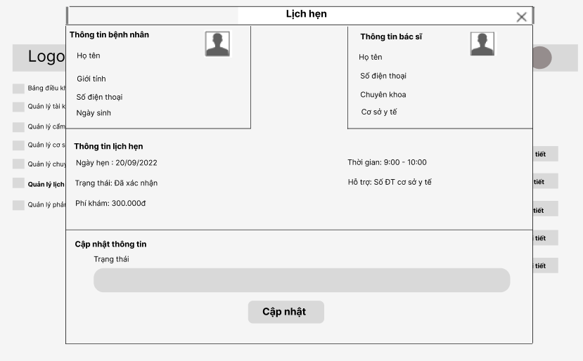

* **Function Details**:

View details of a specific appointment (chosen from the Appointments list) which include:

- Patent information: avatar, name, mobile, gender, date of birth.

- Doctor information: avatar, name, mobile, specialty, medical facility.

- Appointment information: date, time, status, price, mobile of facility

On this screen, admin can change status of appointment if medical facility need helping.

#### 3.12. Feedback List

● **Function trigger**: This function is triggered when the Admin clicks “Quản lý phản hồi” in the navbar.

● **Function description**: Show list of feedback

● **Screen layout**: mock-up prototype of the screen, sample below is for the Feedback List screen

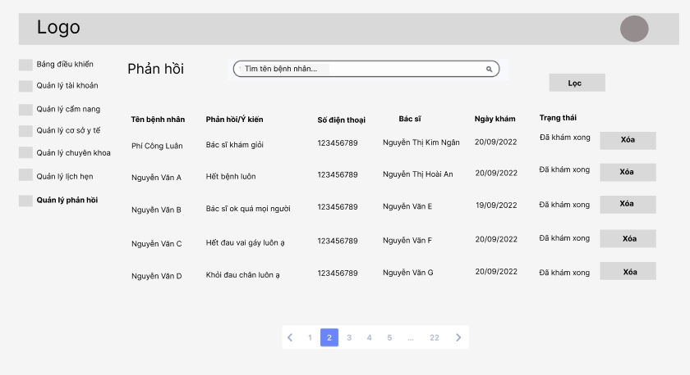

* **Function Details**:

- Show list feedback, specific feedback include: “Tên bệnh nhân”, “Phản hồi/Ý kiến”, “Số điện thoại”, “Bác sĩ”, “Ngày khám”, “Trạng thái”.

- Button “Xóa” for admin to delete the not good feedback.

- Admin can filtered the appointment by date.

#### 3.13. Setting List

#### 3.14. Setting Detail

## 4. Doctor Feature

#### 4.1. Appointment List

●  **Function trigger**: This function is triggered when the Doctor clicks to “Lịch hẹn của tôi”

●  **Function description**: Show list of doctor's appointments

● **Screen layout**: simulated prototype of screen, below sample is for Appointment List screen

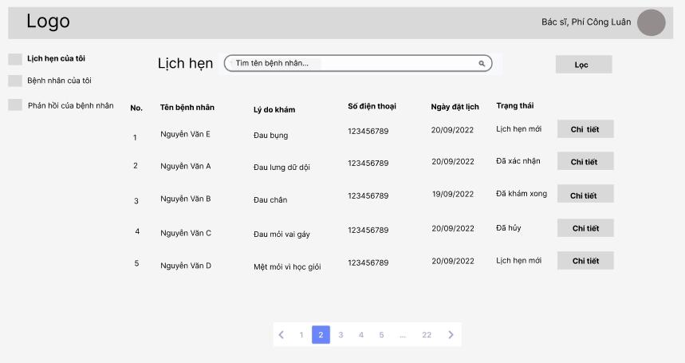

* **Function Details**:

- Show list appointment, specific appointment include: “Tên bệnh nhân”, “Lý do khám”, “Số điện thoại”, “Ngày đặt lịch”, “Trạng thái”.

- Button “Chi tiết” for admin to view detail of the appointment

- Doctor can filtered the appointments by date, status.

- Doctor can search by patient’s name

#### 4.2. Appointment Details

●  **Function trigger**: This function is triggered when the Doctor clicks to “Chi tiết”

●  **Function description**: Show detail of appointment

● **Screen layout**: simulated prototype of screen, below sample is for Appointment Detail screen

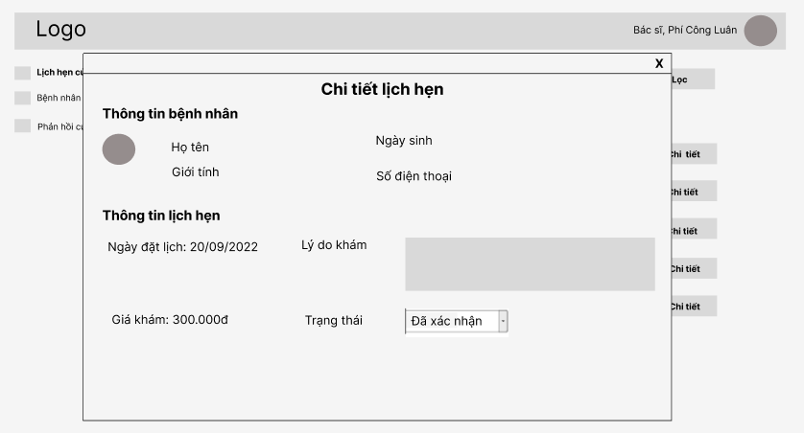

**Function Details:**

- The following information of the patient is shown: name,

DOB, gender, phone number.

- The following information of the appointment is shown: “Ngày đặt lịch”, “Lý do khám”, “Trạng thái”.

- The doctor can change status from “Đã xác nhận” to “Đã khám xong” or “Đã hủy”.

#### 4.3. Patient List

●  **Function trigger**: This function is triggered when the Doctor clicks to “Bệnh nhân của tôi”

●  **Function description**: Show list of patients

● **Screen layout**: simulated prototype of screen, below sample is for Patient List screen

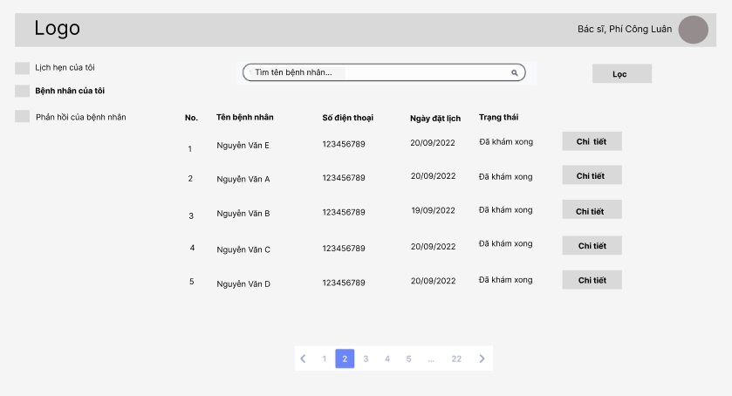

* **Function Details:**

- Patient information which include: name, phone number, date booking appointment, status.

- Button “Chi tiết” for admin to view detail of patient.

- Doctor can search by name of patient, filtered by date.

#### 4.4. Patient Detail

* **Function trigger**: This function is activated when the Doctor clicks on button “Chi tiết”
* **Function description**: View detail & history examination of patient.
* **Screen layout**: simulated prototype of screen, below sample is for Patient Detail screen.

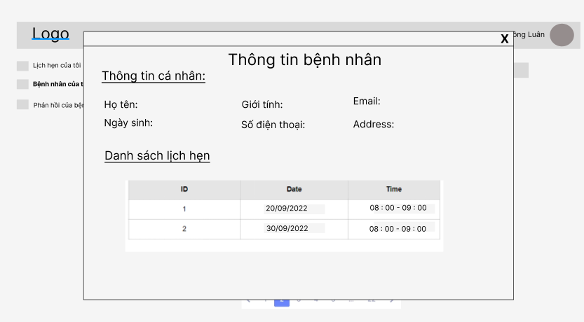

* **Function Details**: View detailed information of the doctor's patient (name, email, mobile, gender, date of birth, address) along with the list of appointments with him/her.

#### 4.5. Feedback List

* **Function trigger**: This function is activated when the Doctor clicks on “Phản hồi của bệnh nhân”
* **Function description**: View information of feedbacks
* **Screen layout**: simulated prototype of screen, below sample is for Feedback List screen.

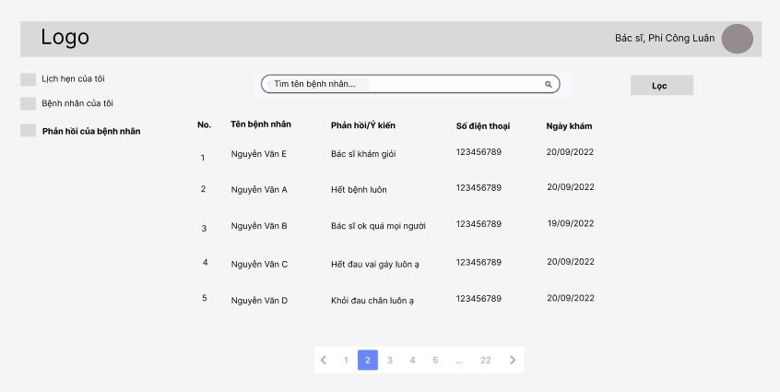

* **Function Details**:

- Show information of feedback includes: “Tên bệnh nhân”, “Phản hồi/Ý kiến”, “Số điện thoại”, “Ngày khám”.

- Doctor can filtered feedback by date.

- Doctor can search feedback by patient’s name.

## 5. Medical Facility

#### 5.1. Dashboard

● **Function trigger**: This function is triggered when the medical facility clicks to “Bảng điều khiển” in navbar

● **Function description**: Show information about medical facility

● **Screen layout**: mock-up prototype of the screen, sample below is for Dashboard screen

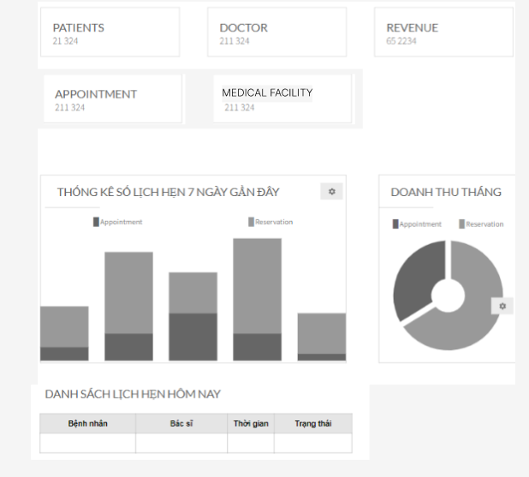

* **Function details**:

- Graphs & Statistics of Doctors, Patients, Appointments, and Revenue

- List of today related appointments (Patient name, doctor name, date/time, Status)

#### 5.2. Booking Schedule

● **Function trigger**: This function is triggered when the medical facility clicks to “Tạo lịch cho bác sĩ” in navbar

● **Function description**: Show Schedule of doctor

● **Screen layout**: mock-up prototype of the screen, sample below is for the Booking Schedule screen

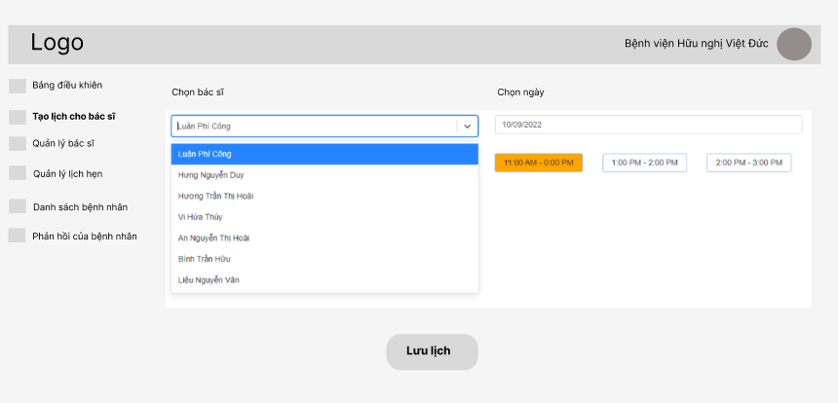

* **Function details**:

- Facility can choose the doctor from list, choose date & click times.

- Button “Lưu lịch” for facility confirm schedule to doctor.

#### 5.3. Doctor List

● **Function trigger**: This function is triggered when the medical facility clicks to “Quản lý bác sĩ” in navbar.

● **Function description**: Show list doctor of medical facility

● **Screen layout**: mock-up prototype of the screen, sample below is for the Doctor List screen

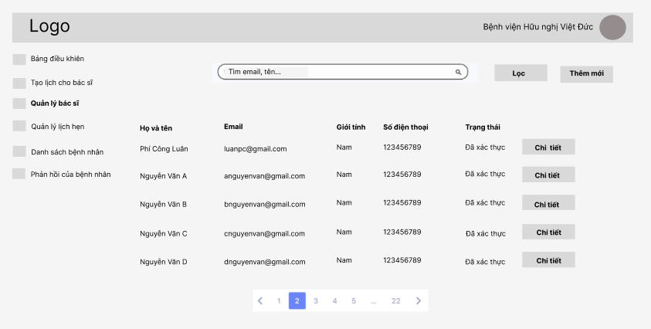

* **Function details**:

- Show information of doctors: name, email, gender, phone number, status account.

- Facility can filtered by status account.

- Searching by email, name.

- Button “Thêm mới” to add new doctor then waiting for admin confirm information of doctor, status will change from “Chưa xác thực” to “Đã xác thực”.

#### 5.4. Doctor Detail

● **Function trigger**: This function is triggered when the user clicks to “Chi tiết” of a doctor

● **Function description**: Show detail information of doctor

● **Screen layout**: mock-up prototype of the screen, sample below is for the Doctor Detail screen

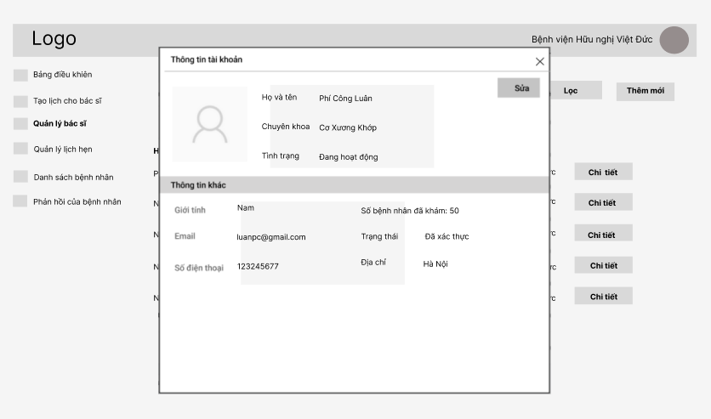

* **Function details**:

- Show information of doctors: avatar, name, specialty, email, gender, phone number, status account, online status, address, number of examinated patients.

#### 5.5. Appointment List

● **Function trigger**: This function is triggered when the medical facility clicks to “Quản lý lịch hẹn” in navbar.

● **Function description**: Show list appointment of facility

● **Screen layout**: mock-up prototype of the screen, sample below is for the Appointment List screen

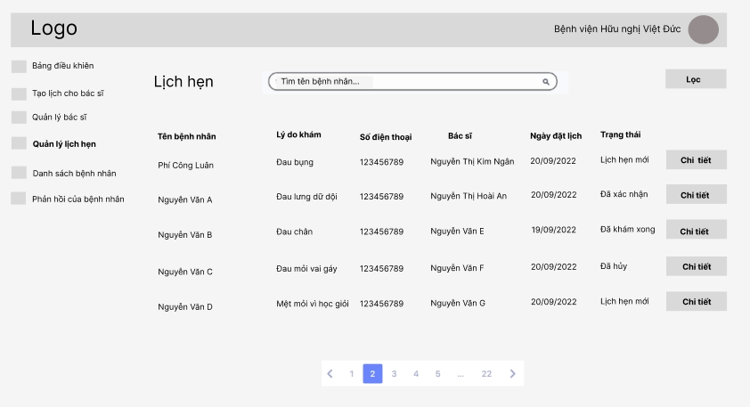

* **Function details**:

- Show some information of appointment: “Tên bệnh nhân”, “Lý do khám”, “Số điện thoại”, “Bác sĩ”, “Ngày đặt lịch”, “Trạng thái”

- Show button “Lọc” for facility to filtered by date, status.

- Show button “Chi tiết” for facility to view detail of appointment.

- Medical facility can search appointment by patient’s name.

#### 5.6. Appointment Detail

● **Function trigger**: This function is triggered when the medical facility clicks “Chi tiết” of an appointment.

● **Function description**: Show detail of appointments

● **Screen layout**: mock-up prototype of the screen, sample below is for the Appointment Detail screen



* **Function Details**:

View details of a specific appointment (chosen from the Appointments list) which include:

- Patent information: avatar, name, mobile, gender, date of birth.

- Doctor information: avatar, name, mobile, specialty, medical facility.

- Appointment information: date, time, status, price, mobile of facility

On this screen, medical facility can change status if doctor have request.

#### 5.7. Patient List

● **Function trigger**: This function is triggered when the medical facility clicks “Danh sách bệnh nhân” in navbar.

● **Function description**: Show list of patient.

● **Screen layout**: mock-up prototype of the screen, sample below is for the Patient List screen

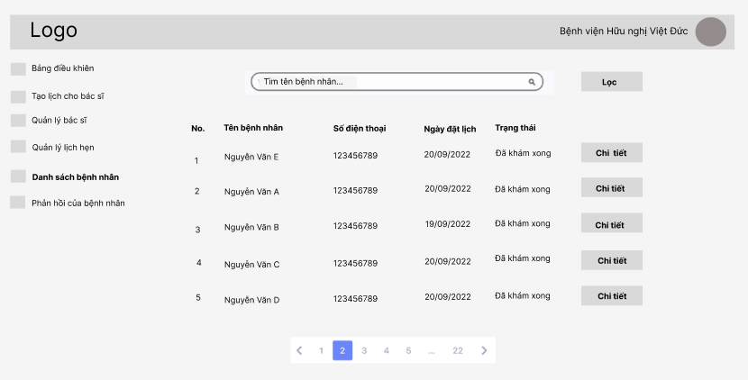

* **Function Details**:

- Patient information which include: name, phone number, date booking appointment, status.

- Button “Chi tiết” for admin to view detail of patient.

- Medical facility can search by name of patient, filtered by date.

#### 5.8. Patient Detail

● **Function trigger**: This function is triggered when the medical facility clicks “Chi tiết” of patient.

● **Function description**: Show detail of patient.

● **Screen layout**: mock-up prototype of the screen, sample below is for the Patient Detail screen

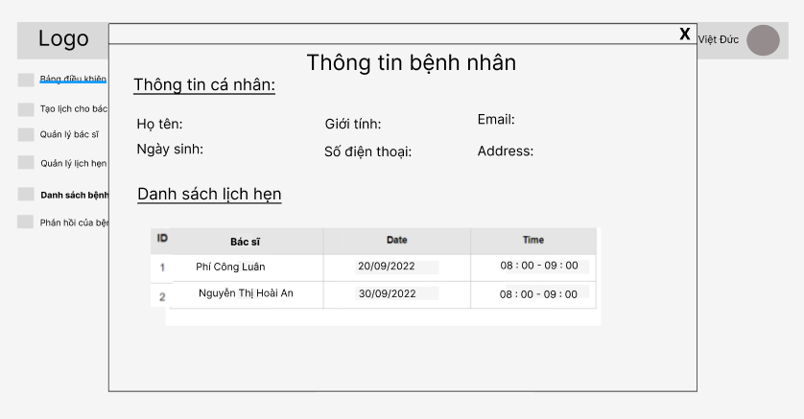

* **Function Details**:
* View detailed information of the doctor's patient (name, email, mobile, gender, date of birth, address) along with the list of appointments with him/her.

#### 5.9. Feedback List

● **Function trigger**: This function is triggered when the medical facility clicks “Phản hồi của bệnh nhân” in navbar.

● **Function description**: Show list of feedback.

● **Screen layout**: mock-up prototype of the screen, sample below is for the Feedback List screen

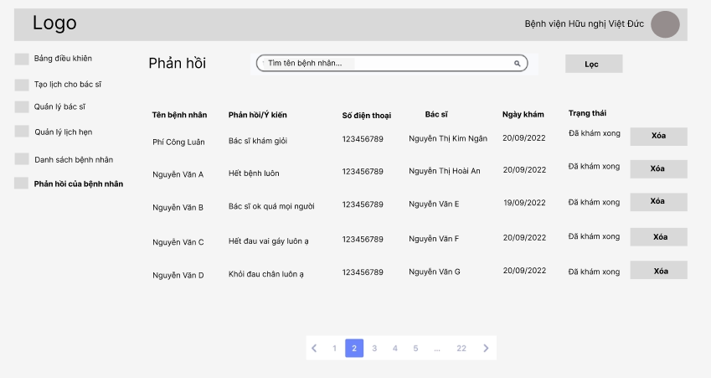

* **Function Details**:
* Show list feedback, specific feedback include: “Tên bệnh nhân”, “Phản hồi/Ý kiến”, “Số điện thoại”, “Bác sĩ”, “Ngày khám”, “Trạng thái”.
* Button “Xóa” for medical facility to delete the not good feedback.
* Medical facility can filtered the appointment by date.

## 6. Patient Feature

#### 6.1. Booking Appointment

●  **Function trigger**: This function is triggered when the patient clicks to Time in the schedule of a doctor.

● **Function description**: Show form to patient fills in information.

● **Screen layout**: simulated prototype of screen, below sample is for Booking Appointment screen

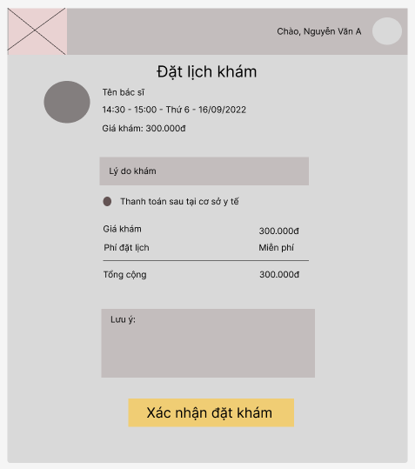

* **Function Details**:
* Show information of appointment includes:
* Doctor information: avatar, name, price
* Date, time booking, type payment, total payment.
* Button “Xác nhận đặt khám” for patient confirm booking the appointment

#### 6.2. Appointment List

●  **Function trigger**: This function is triggered when the patient clicks “Danh sách lịch hẹn” in navbar

● **Function description**: Show list appointment

● **Screen layout**: simulated prototype of screen, below sample is for Appointment List screen

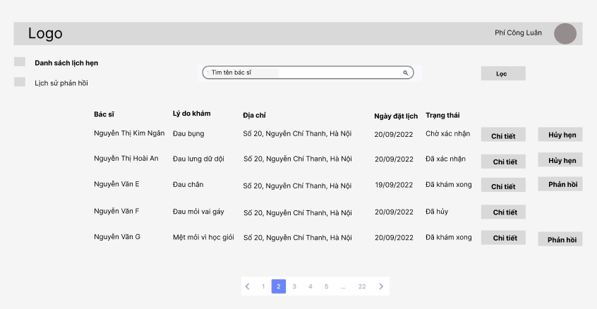

* **Function Details**:
* Show information of appointment includes: “Bác sĩ”, “Lý do khám”, “Địa chỉ”, “Ngày đặt lịch”, “Trạng thái”.
* Show button “Hủy hẹn” for patient can cancel the appointment if status is “Chờ xác nhận” or “Đã xác nhận”.
* Patient can filter the appointment by date.
* Patient can search by doctor’s name

#### 6.3. Appointment Detail

●  **Function trigger**: This function is triggered when the patient clicks “Chi tiết” of an appointment

● **Function description**: Show detail of appointment

● **Screen layout**: simulated prototype of screen, below sample is for Appointment Detail screen

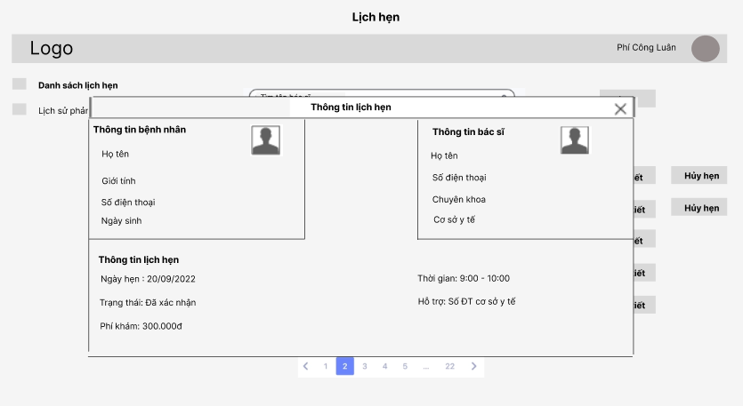

* **Function Details**:
* View details of a specific appointment (chosen from the Appointments list) which include:
* Patent information: avatar, name, mobile, gender, date of birth.
* Doctor information: avatar, name, mobile, specialty, medical facility.
* Appointment information: date, time, status, price, mobile of facility

#### 6.4. Feedback History

●  **Function trigger**: This function is triggered when the patient clicks “Lịch sử phản hồi” in navbar

● **Function description**: Show list feedback of own patient

● **Screen layout**: simulated prototype of screen, below sample is for Feedback History screen

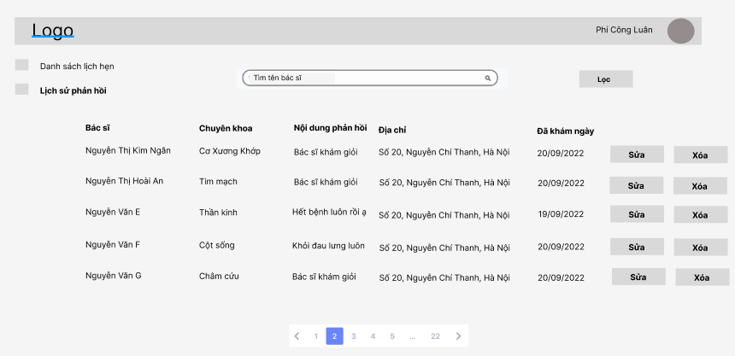

* **Function Details**:
* Display information includes: “Bác sĩ”, “Chuyên khoa”, “Nội dung phản hồi”, “Địa chỉ”, “Đã khám ngày”
* Show button “Sửa”/ “Xóa” for patient to edit/ delete the feedback.